7TH EXPERIMENT

1.
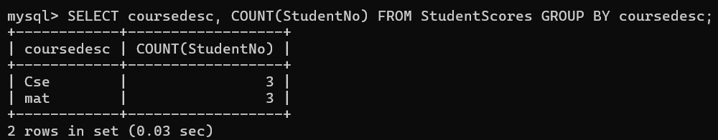
2.
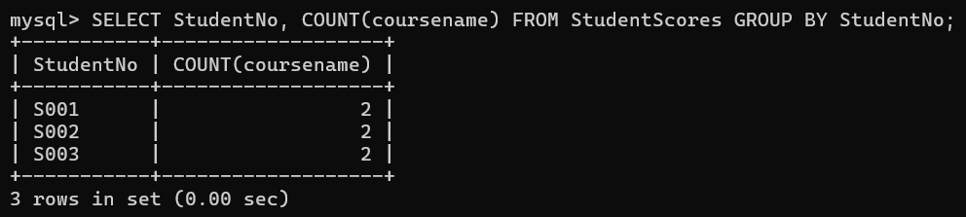
1.
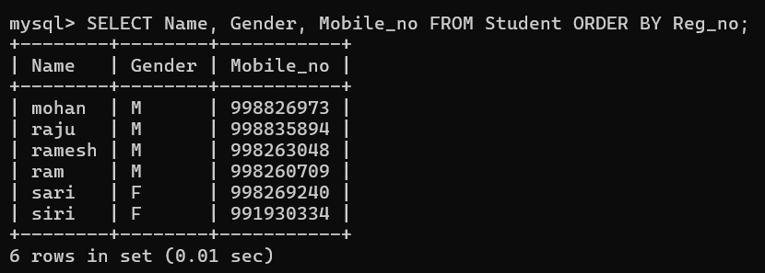
2.
